Midterm Examination

Date: April 2020; Duration: 120 minutes

**Open exam**

|  |  |
| --- | --- |
| **SUBJECT: Fundamental of Programming (IT149IU)** | |
| School of CSE Approval  Signature  Full name: | Lecturer:  Signature    Full name: Lê Thanh Sơn |
| Proctor 1  Signature  Full name: | Proctor 2  Signature  Full name: |
| **STUDENT INFO** | |
| **Student name:Võ Văn Việt**  **Student ID:ITDSIU18043** | |

# INSTRUCTIONS: total grade is 100 (20% of course grade)

1. *Purpose:*

* Test your understanding in C Programming
* Ability to solve programming problems using C Programming language

1. *Requirement:*

* Write your answers CLEAN and TIDY in the given blank spaces.
* **Submit the finished file along with your source code files to blackboard**
* Rename the doc file with the following format: **FunProgMidterm_Yourname_studnetID.docx.** Example: FunProgMidterm_NguyenVanA_IT12345.docx

**PART I** (20 pts):Write your answer in the given black spaces

1. (10 pts) What is the purpose of the function ***isSomething*** below?

|  |
| --- |
| **Answer:**  **The purpose of the function isSomething above is check if the input number is prime number or not.**  **Return 0 if it is not prime number. Return 1 if it is prime number.** |

1. (10 pts) What is the purpose of the function ***isSomething*** below?

|  |
| --- |
| **Answer:**  **The purpose of the function isSomething above is check if the series of numbers is symmetric or not.**  **Return 0 if it is not symmetric. Return 1 if it is symmetric.** |

**PART II** (80pts): Copy and paste your source code here and attach the .c files when submit

1. (30 pts) Write the following functions:
   1. void inputArray(int arr[ ], int size) to input an array of size elements
   2. void inputArray(int arr[ ], int size, int range) to create an array with size elements of random inegers from 1 to range
   3. void outputArray(int arr[ ], size) to output all elements of an array with size elements
2. (30 pts) Input an array of n positive integers. Write a function to find the index of the first prime number, the result should be -1 if there is no prime number in the array

Example: arr = [1, 19, 5, 6, 12, 11, 17, 9] 🡪 result = 1 (1st prime of the array is 19, index is 1)

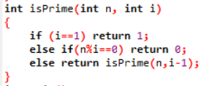

1. (20 pts) Input an array of n integers, n is odd. Write a function to skip the integer at the center of the array and sort the 1st half increasing order, 2nd half decreasing.

Example: 5 2 3 1 **2** 8 6 9 0 🡪 1 2 3 5 **2** 9 8 6 0

**Answer:**

**1.Write the following function:**

**a/** void inputArray(int arr[ ], int size) to input an array of size elements

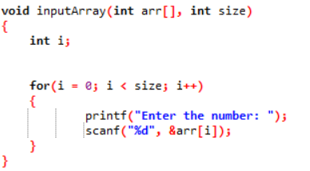

b/ void inputArray(int arr[ ], int size, int range) to create an array with size elements of random integers from 1 to range

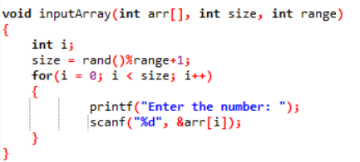

c/ void outputArray(int arr[ ], size) to output all elements of an array with size elements

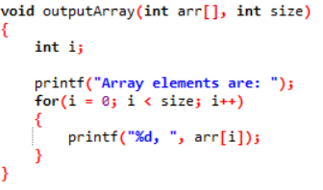

2.(30 pts) Input an array of n positive integers. Write a function to find the index of the first prime number, the result should be -1 if there is no prime number in the array

Example: arr = [1, 19, 5, 6, 12, 11, 17, 9] 🡪 result = 1 (1st prime of the array is 19, index is 1)

3. (20 pts) Input an array of n integers, n is odd. Write a function to skip the integer at the center of the array and sort the 1st half increasing order, 2nd half decreasing.

Example: 5 2 3 1 **2** 8 6 9 0 🡪 1 2 3 5 **2** 9 8 6 0

